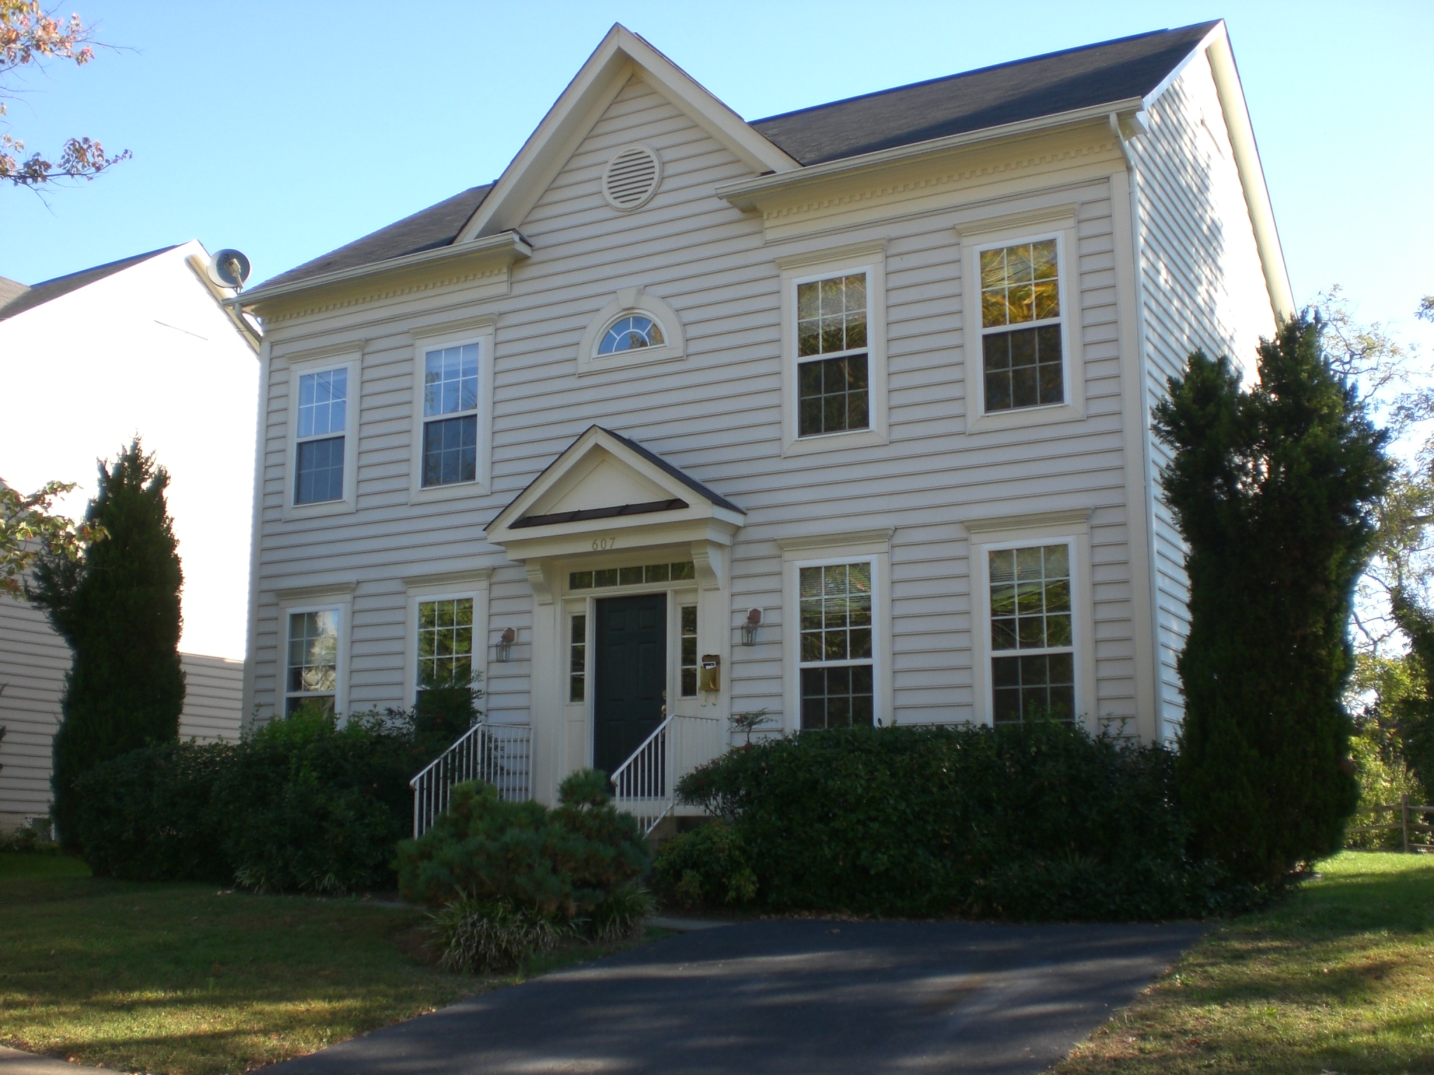
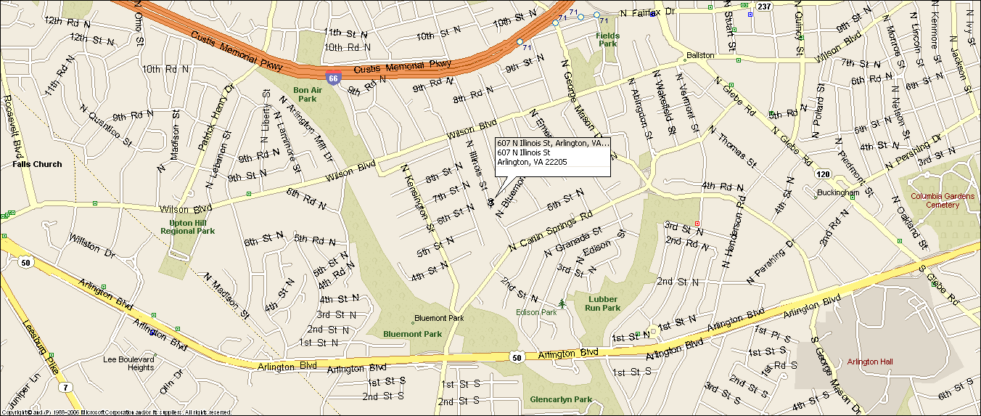
607 N. Illinois Street
Arlington, VA 22205
Newer Colonial
Great location: Close to DC, walk to Ballston Metro
- Five bedrooms, three full baths, 1 half bath.
- Lower level au pair suite / guest suite.
- Large kitchen w/ island, granite & newer SS appliances.
- Direct access to bike / walking path, new storage shed.
- Large landscaped yard, rear flagstone patio, built in fire pit & brand new Tiki Bar.
- Hardwood floors main level & upper level, new carpet on the lower level.
- Established quiet neighborhood, cul-de-sac location.
- Excellent Schools: Ashlawn Elementary, Kenmore MS, & Washington Lee HS
- Lease terms: 1 year minimum, no smoking, no pets, no use of fire place

RENT: $4,700.00 / month + utilities, contact Lyndsay Saffer 703-906-3082
Email: safferlyndsay@gmail.com

